1.Working with numpy arrays
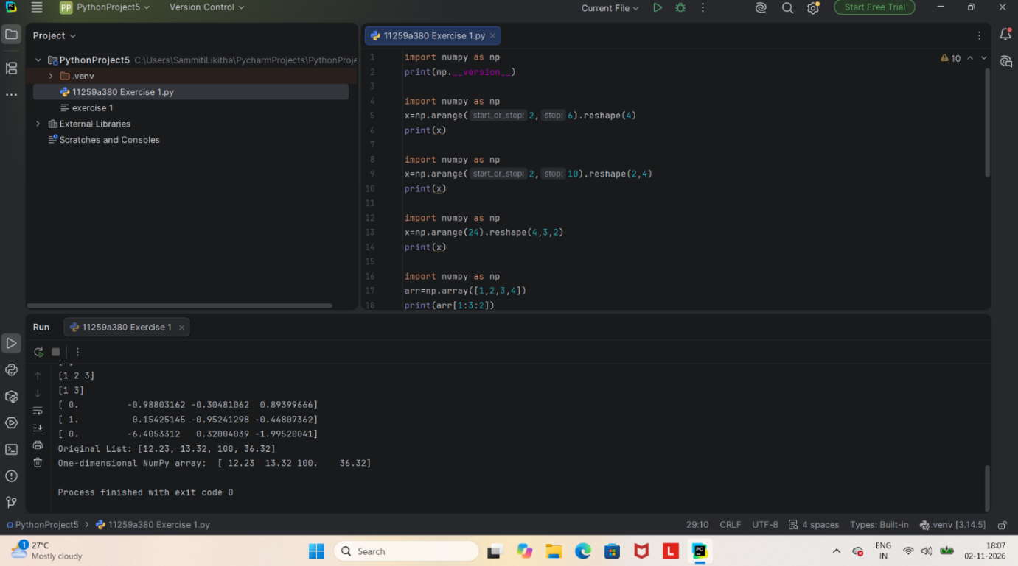

2.Working of pandas dataframe
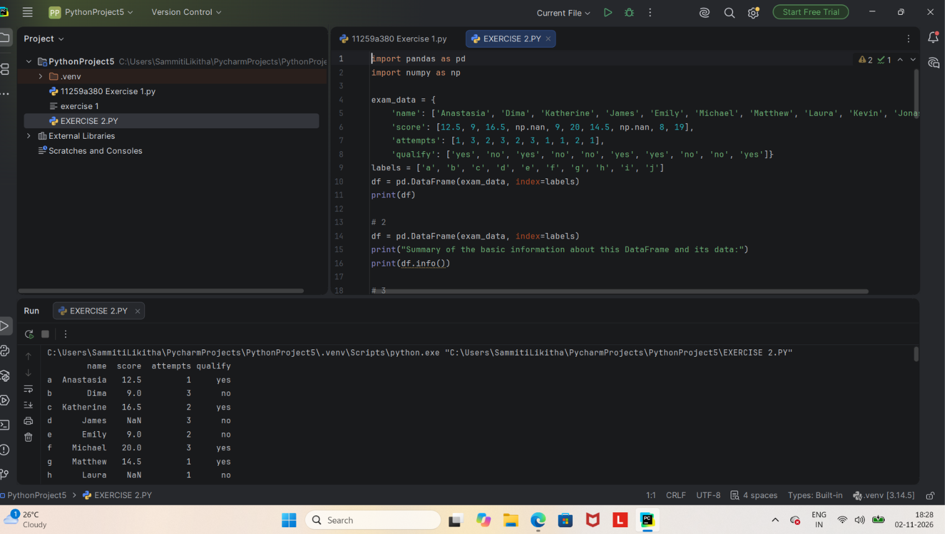

3.Basic scenario based programs using python for datascience
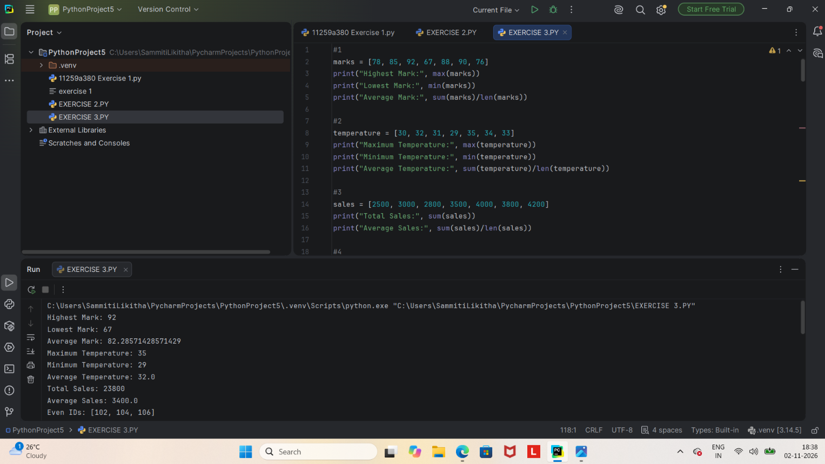

4.Perform data preprocessing on a given dataset
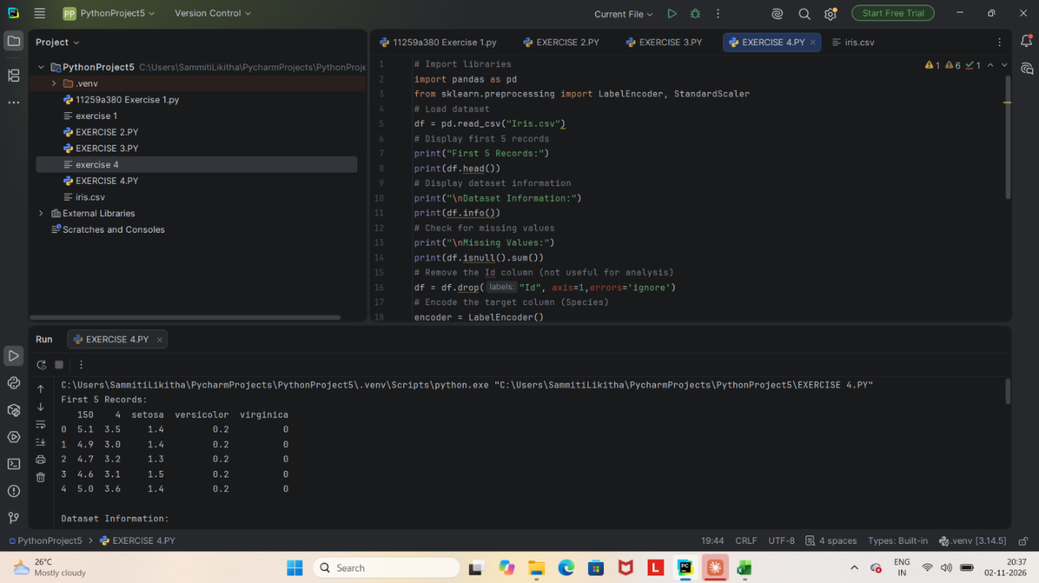

5.Dataset Splitting and cross - validation using iris dataset
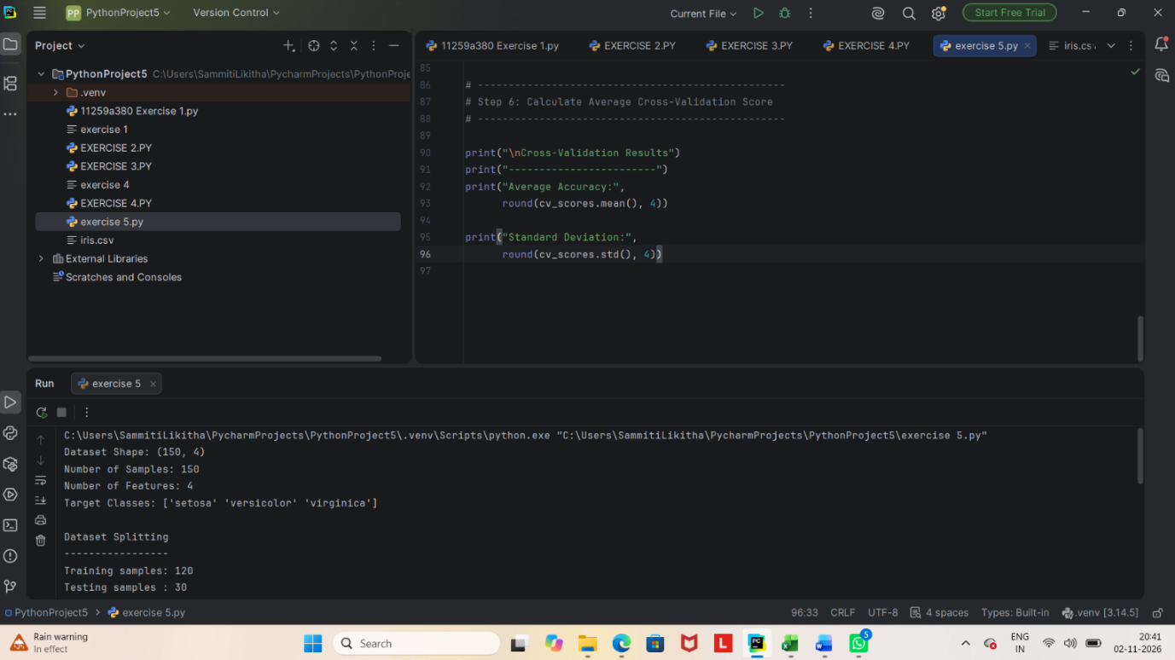

6.Linear regression using iris dataset
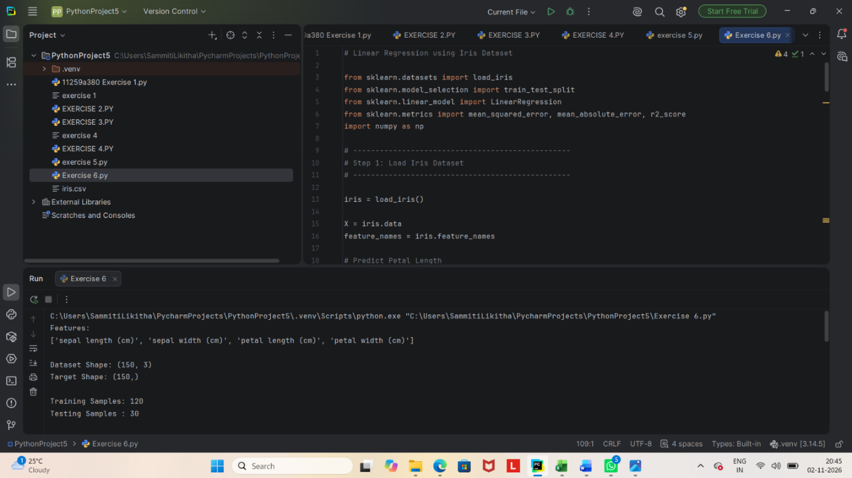

7.Implement a classification using K-Nearest neighbors (KNN) and compute evaluation metrics
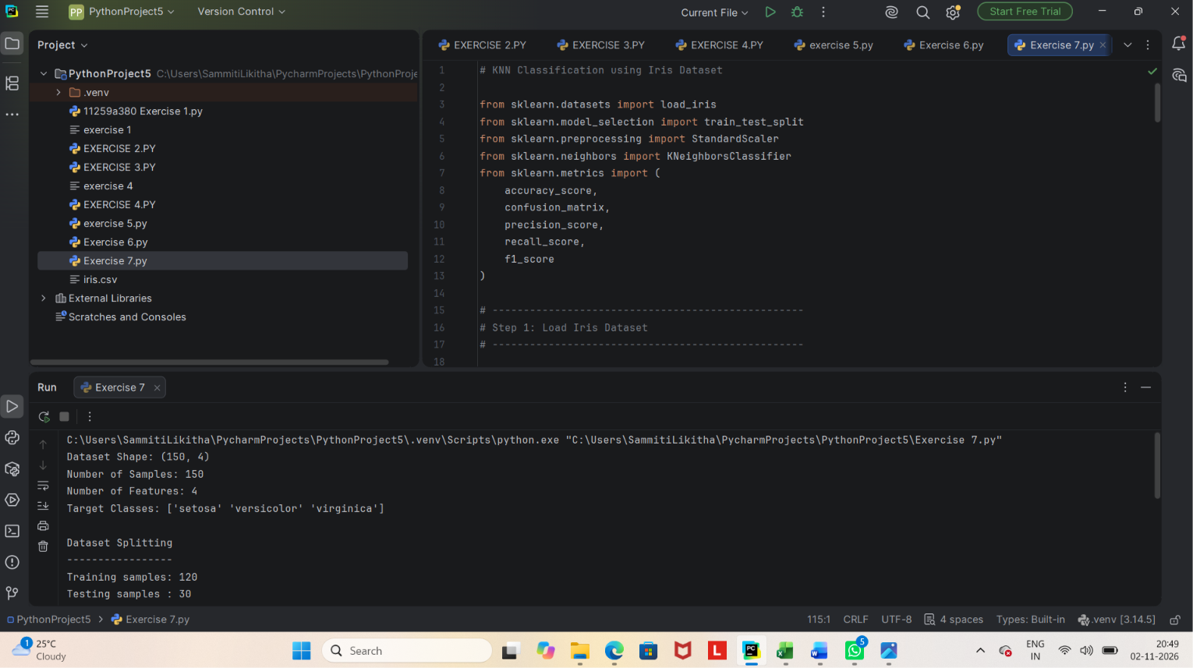

8.SVM Classification using iris dataset
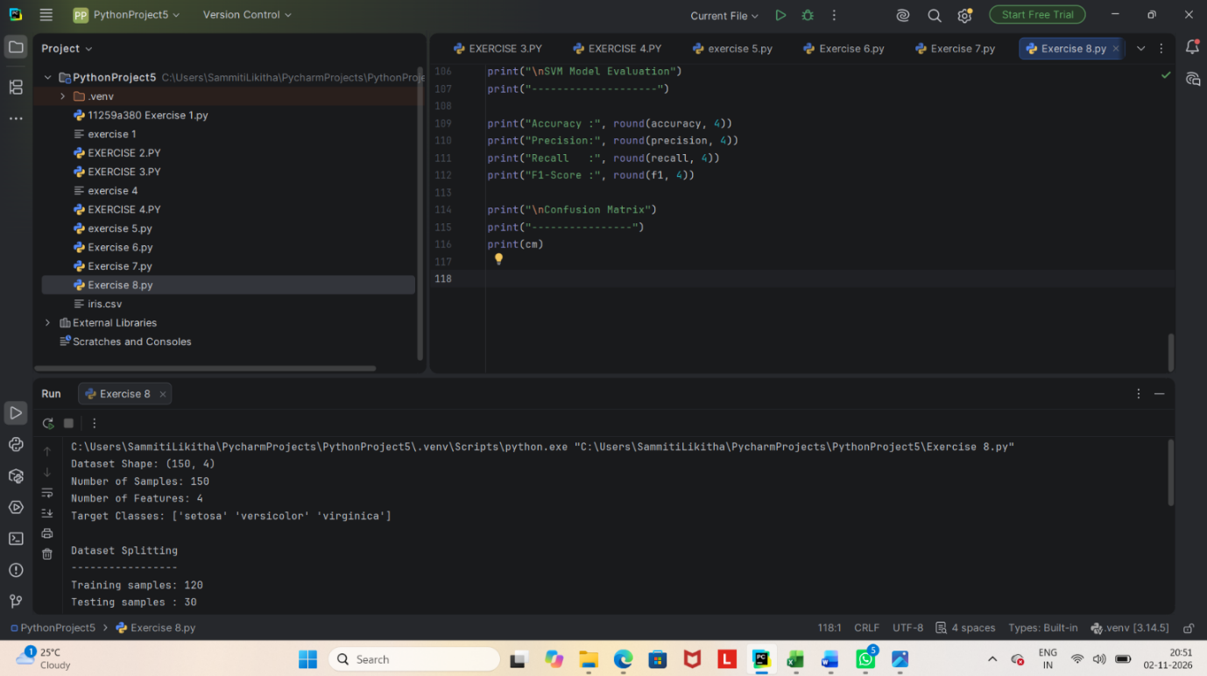

9.Implement K-Means clustering using iris dataset
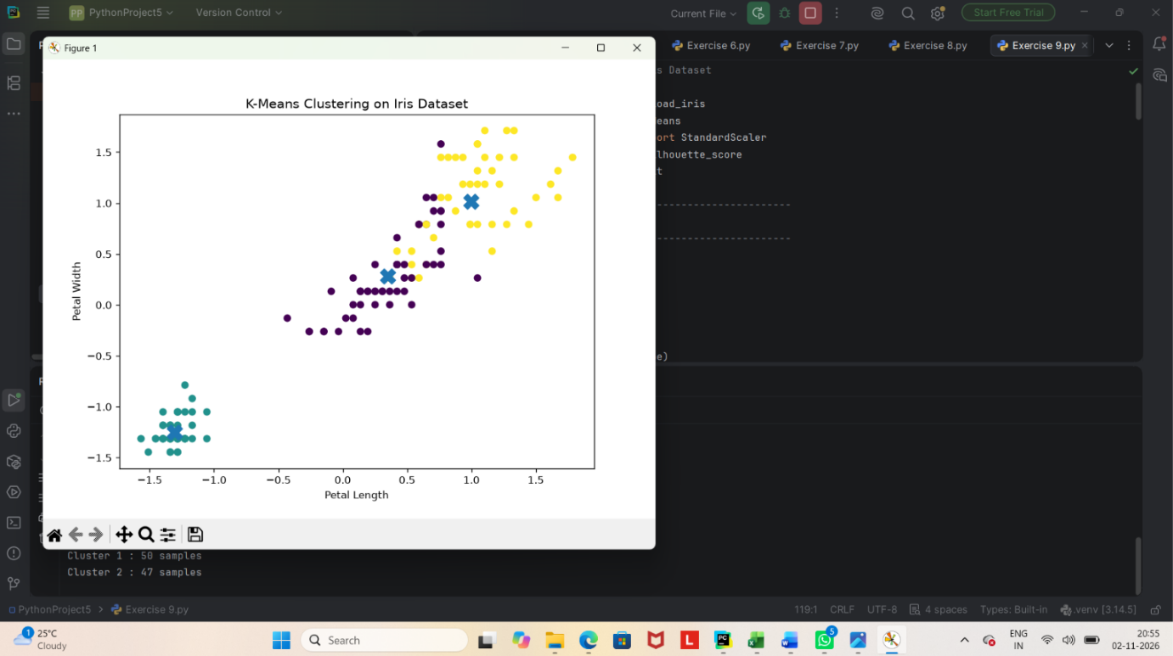

10.Hierarchical clustering using iris dataset
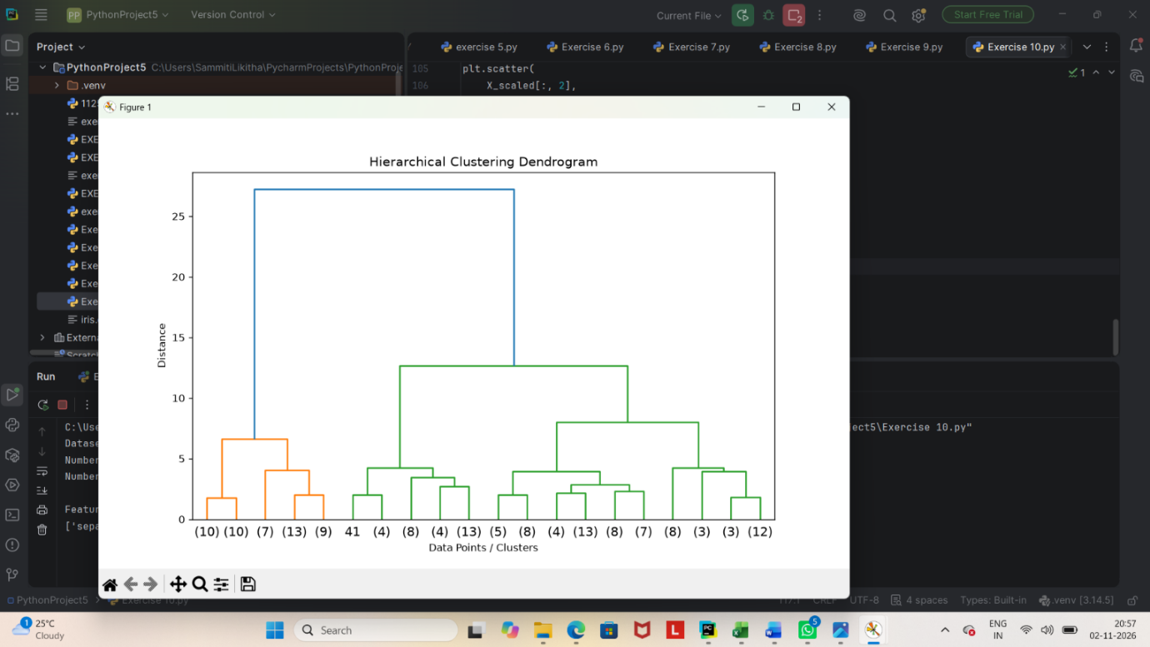

11.Implement Random forest and analyze performance
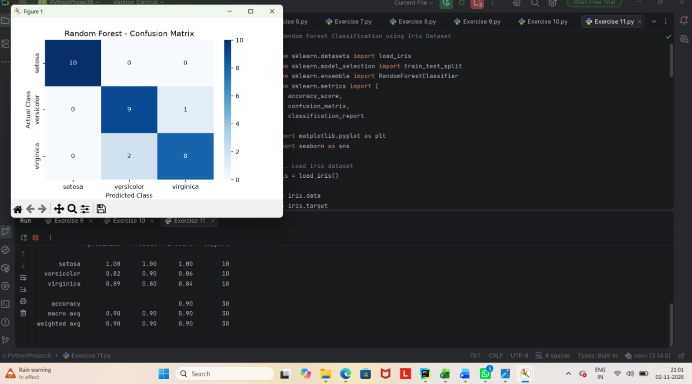

12.Implement boosting techniques and compare results
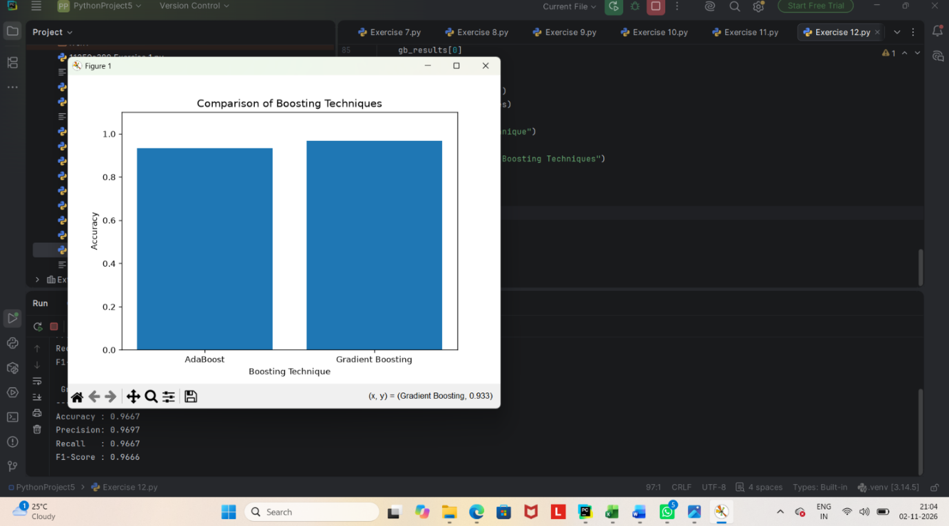

13.Implement a basic reinforcement learning model python program
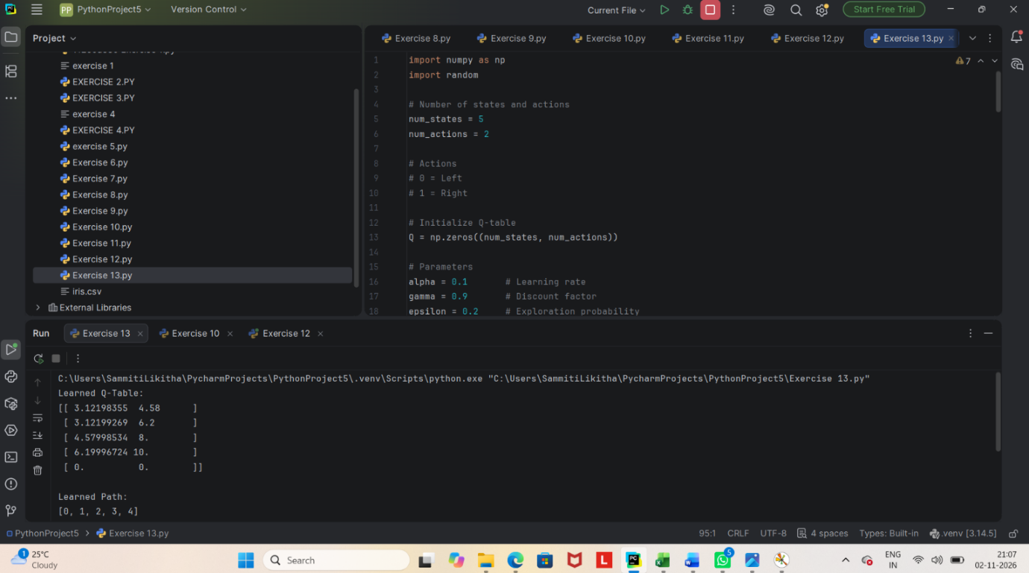

14.Build a neural network using tensorflow/keras


